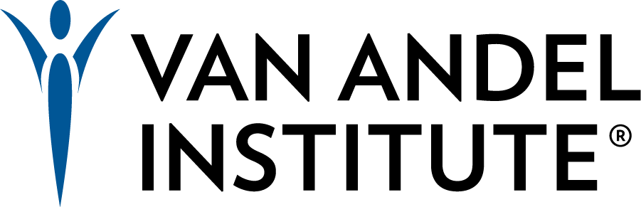
Vivarium Manager
Van Andel Institute (VAI), a leading independent biomedical research and science education institution seeking to hire a full-time Vivarium Manager to help lead our rodent barrier facilities. This manager will be an essential partner to the vivarium leadership ensuring continued and evolving excellence when it comes to animal support for our research studies.
VAI is dedicated to determining the epigenetic, genetic, molecular, and cellular origins of cancer, Parkinson’s, and other diseases, and translating those findings into effective therapies. The Institute is home to more than 400 scientists and support staff that work in on-site laboratories and in collaborative partnerships that span the globe.
As a Vivarium Manager, you will be responsible for supporting rodent and zebrafish research by assisting in the management of VAI’s animal facility. Your primary responsibilities will be the day-to-day animal welfare, environmental quality, supply logistics, work scheduling, training, and performance management of the animal caretaking team. You will be part of an exceptional team of experienced professional and technically skilled animal care staff as well as a key member of the leadership team that works directly with the research labs on special projects and research support. This leadership team strengthens VAI’s ability to remain in compliance with all federal and state regulations and guidelines while also maintaining the high standards of AAALAC accreditation.
Your primary responsibilities in this role will be:
- Scheduling and managing labor distribution accordingly. This includes matching skilled staff to the needs of the various labs for technical/research support.
- Overseeing husbandry, sanitization practices, and technical/research support according to internal SOPs and external regulations.
- Assuring research activities follow current policies, regulations, and guidelines governing the care and use of animals, which includes writing and maintaining internal vivarium SOPs
- Maintaining inventory, equipment, facility set-up, and records relating to operations; including purchasing animals and general supplies, ensuring proper functioning of facility equipment, and coordinating equipment repair and maintenance
- Hiring, supervising, and training the vivarium staff, focusing on Assistant Laboratory Animal Technicians (ALAT)
You might be the right person for this role if you have:
- Critical skillsets to motivate and lead others toward the accomplishment of individual and shared objectives
- Demonstrated ability to train staff in all areas of animal care and laboratory techniques
- Experience with managing or supporting an aquatics facility
- A strong commitment to building and maintaining a positive work environment
- Strong written and oral communication skills
- Attention to detail
- A Bachelor’s degree in biological or animal science or a related field
- AALAS certification at a LATg level
- 5+ years of related experience working with laboratory animals
- At least 3 years of supervisory experience
What we offer:
Training
On-site and external training is available. Funding is available with departmental and Institute support for off-site training. We are dedicated to training and helping advance your skills in developing and updating SOPs for the facility, Vivarium staff onboarding, and training practices, and developing operational budgets.
Salary and Compensation
All full-time employees of Van Andel Institute are eligible for benefits, effective Day One! The hourly rate you can expect in this role is based on your experience and skills, however, we are targeting $70,000-$110,000. VAI Employees are eligible for an annual cost of living increases and performance management raises.
Relocation Assistance
If you are relocating you will receive a lump sum payment and be eligible to utilize the Institute paid contracted services of a Relocation Specialist.
Stable Base Funding
This position is funded through the Institute’s endowment. This position is not grant-funded.
How to Apply
- For Online application, click below https://jobs.silkroad.com/VAI/VAICareerSite/jobs/984
- Cover Letter indicating why you are interested in this position and how your experience exhibits your qualifications for this role.
- Resume/Curriculum Vitae
- Names and contact information for 3 professional references. References will not be contacted without advance notice.
This position will be open until filled. If you have any difficulty uploading your application or have any questions, please email Megan Doerr at Megan.Doerr@vai.org.
At Van Andel Institute, the health and safety of our people are our number one priority. As a condition of employment at Van Andel Institute, all employees are required to be fully vaccinated against COVID-19. “Full vaccination” is defined as two weeks after both doses of a two-dose vaccine or two weeks since a single-dose vaccine has been administered. We are a drug and alcohol-free employer; all prospective new employees undergo a urinalysis/drug test as part of our pre-employment process.
VAI is committed to achieving excellence through increasing diversity. We actively encourage applications from women, persons of color, persons with disabilities, and other underrepresented groups. We are an Equal Employment Opportunity (EEO) and Vietnam Era Veterans Readjustment Assistance Act (VEVRAA) Employer.
About Grand Rapids, MI
Van Andel Research Institute is located in downtown Grand Rapids, Michigan. A remarkable combination of a cosmopolitan atmosphere and small-town warmth, Grand Rapids is known for its philanthropic and sustainability-driven community. It’s fun affordable and family-friendly.
Located on the banks of the Grand River, Grand Rapids offers all the big-city excitement you'd expect from a million-resident metropolis, featuring hundreds of restaurants and nightspots, theatres, museums, sports, and concerts. The safe and clean downtown is surrounded by an eclectic mix of walkable neighborhoods and natural areas.
With a medical and life sciences industry boom, strong entrepreneurial activity, dedication to green building and living, and innovative employers, Grand Rapids' diverse economy continues to grow, offering endless career opportunities.
This position is located at 333 Bostwick Avenue NE, Grand Rapids, MI. View the Google Map in full screen.

